**First task.**

Run a query that displays all products starting with the letter B:

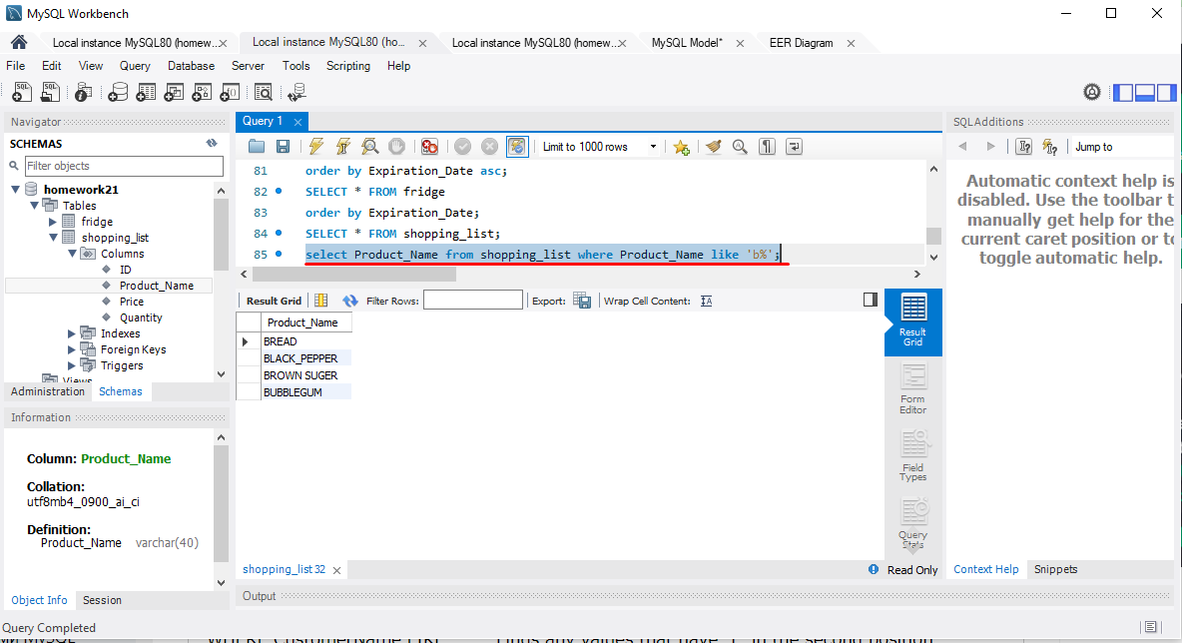

Use the JOIN operator to make a query to find products from the shopping list that are already in the fridge:

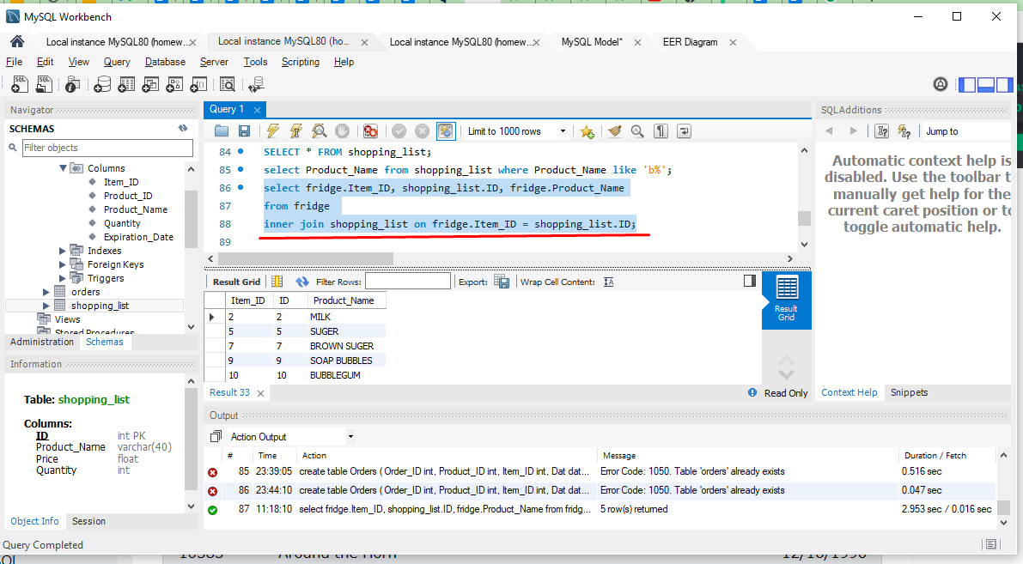

**Second level.**

Display information about products that are not in the fridge and need to be bought (from the Shopping_List and Fridge tables):

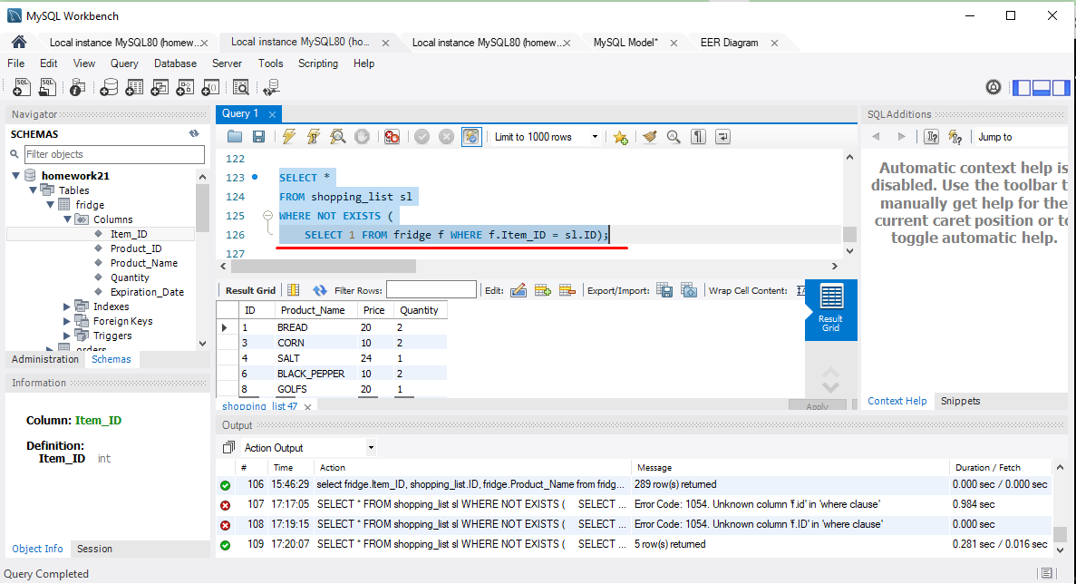

**Third level.**

Create an Order table in an existing database with fields (Order_ID, Product_ID, Item_ID, Date, Quantity):

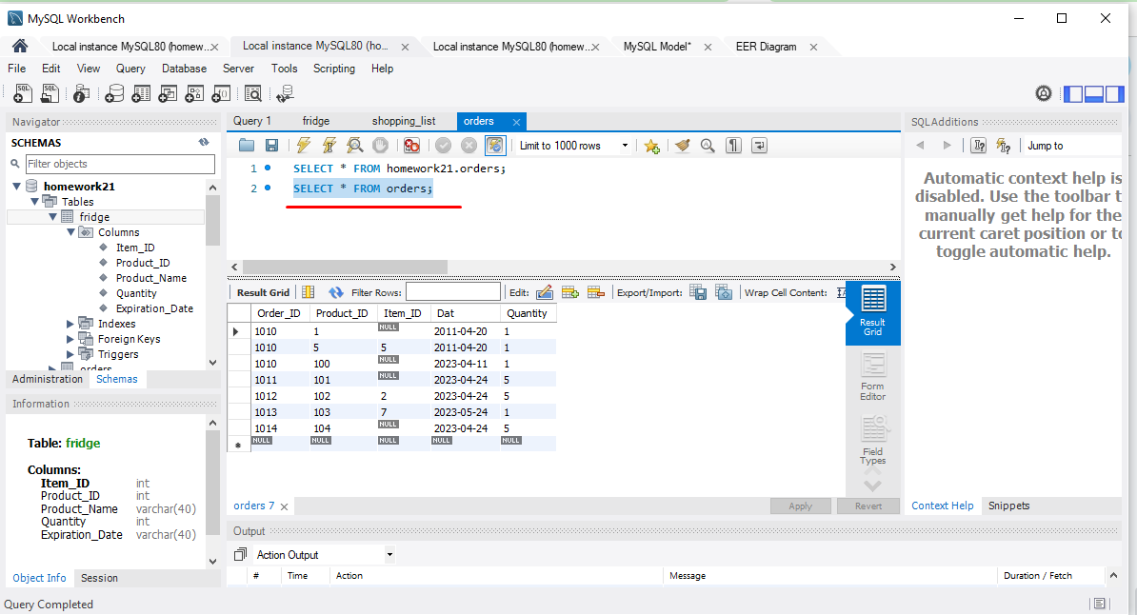

Add to it all the products that are in the Shopping_List and Fridge tables.

I divide this task into two tasks.

The first task is to join the Shopping_List and Frige tables using the Left join operator:

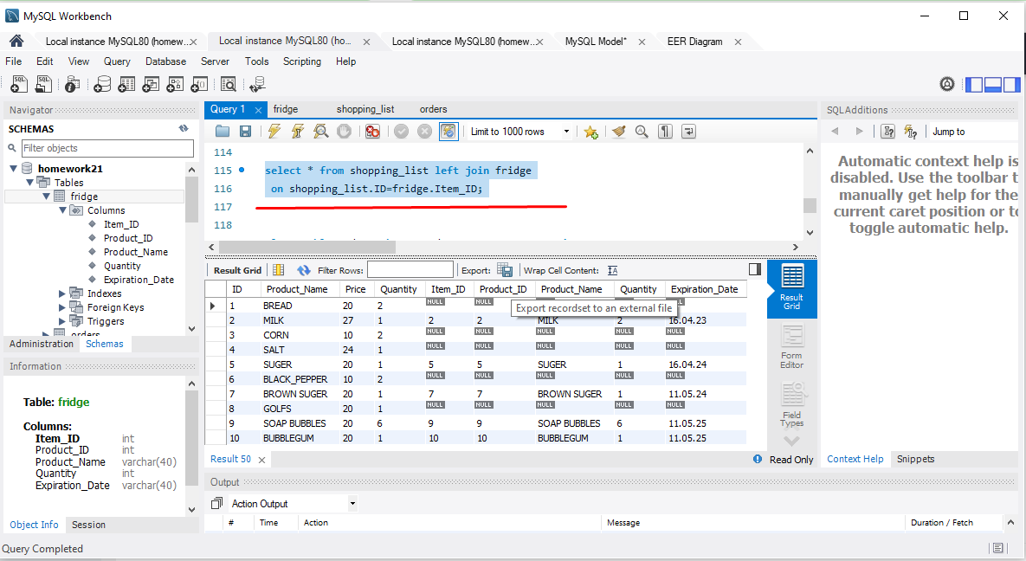

поки не доробила, здається я рухаюсь у не вірному напрямку у цьому завданні…